29-Jun-23 4:08:16 PM
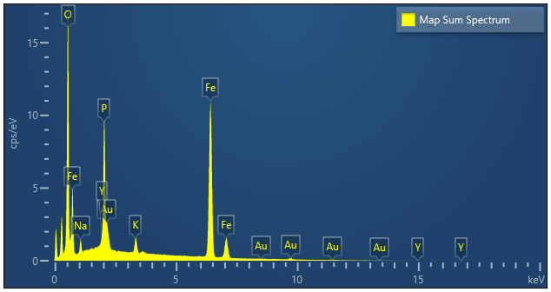

Label: | Map Sum Spectrum
Source: | Acquired
Created: | 29-Jun-23 4:08:16 PM
Livetime: | 78.7s
Process Time: | 4
Accelerating Voltage: | 15.00kV
Magnification: | 2000 x
Working Distance: | 15.2mm
Stage X: | -6.495mm
Stage Y: | 1.9mm
Stage Z: | 18.0mm
Stage Tilt: | 0.00°
Specimen Tilt (degrees): | 0.00
Stage Rotate: | 0.0°
Elevation (degrees): | 29.0
Azimuth (degrees): | 0.0
Number Of Channels: | 2048
Energy Range (keV): | 20 keV
Energy per Channel (eV): | 10.0eV
Detector Type: | X-MaxN 150
Detector Type Id: | 34
Window Type: | SATW
Pulse Pile Up Correction: | Disabled
Primary Detector: | EDS1 90Deg
Primary Detector Serial Number: | 71760-X150-1

